Ingeteam will once again be present at the Intersolar Europe fair in Munich.
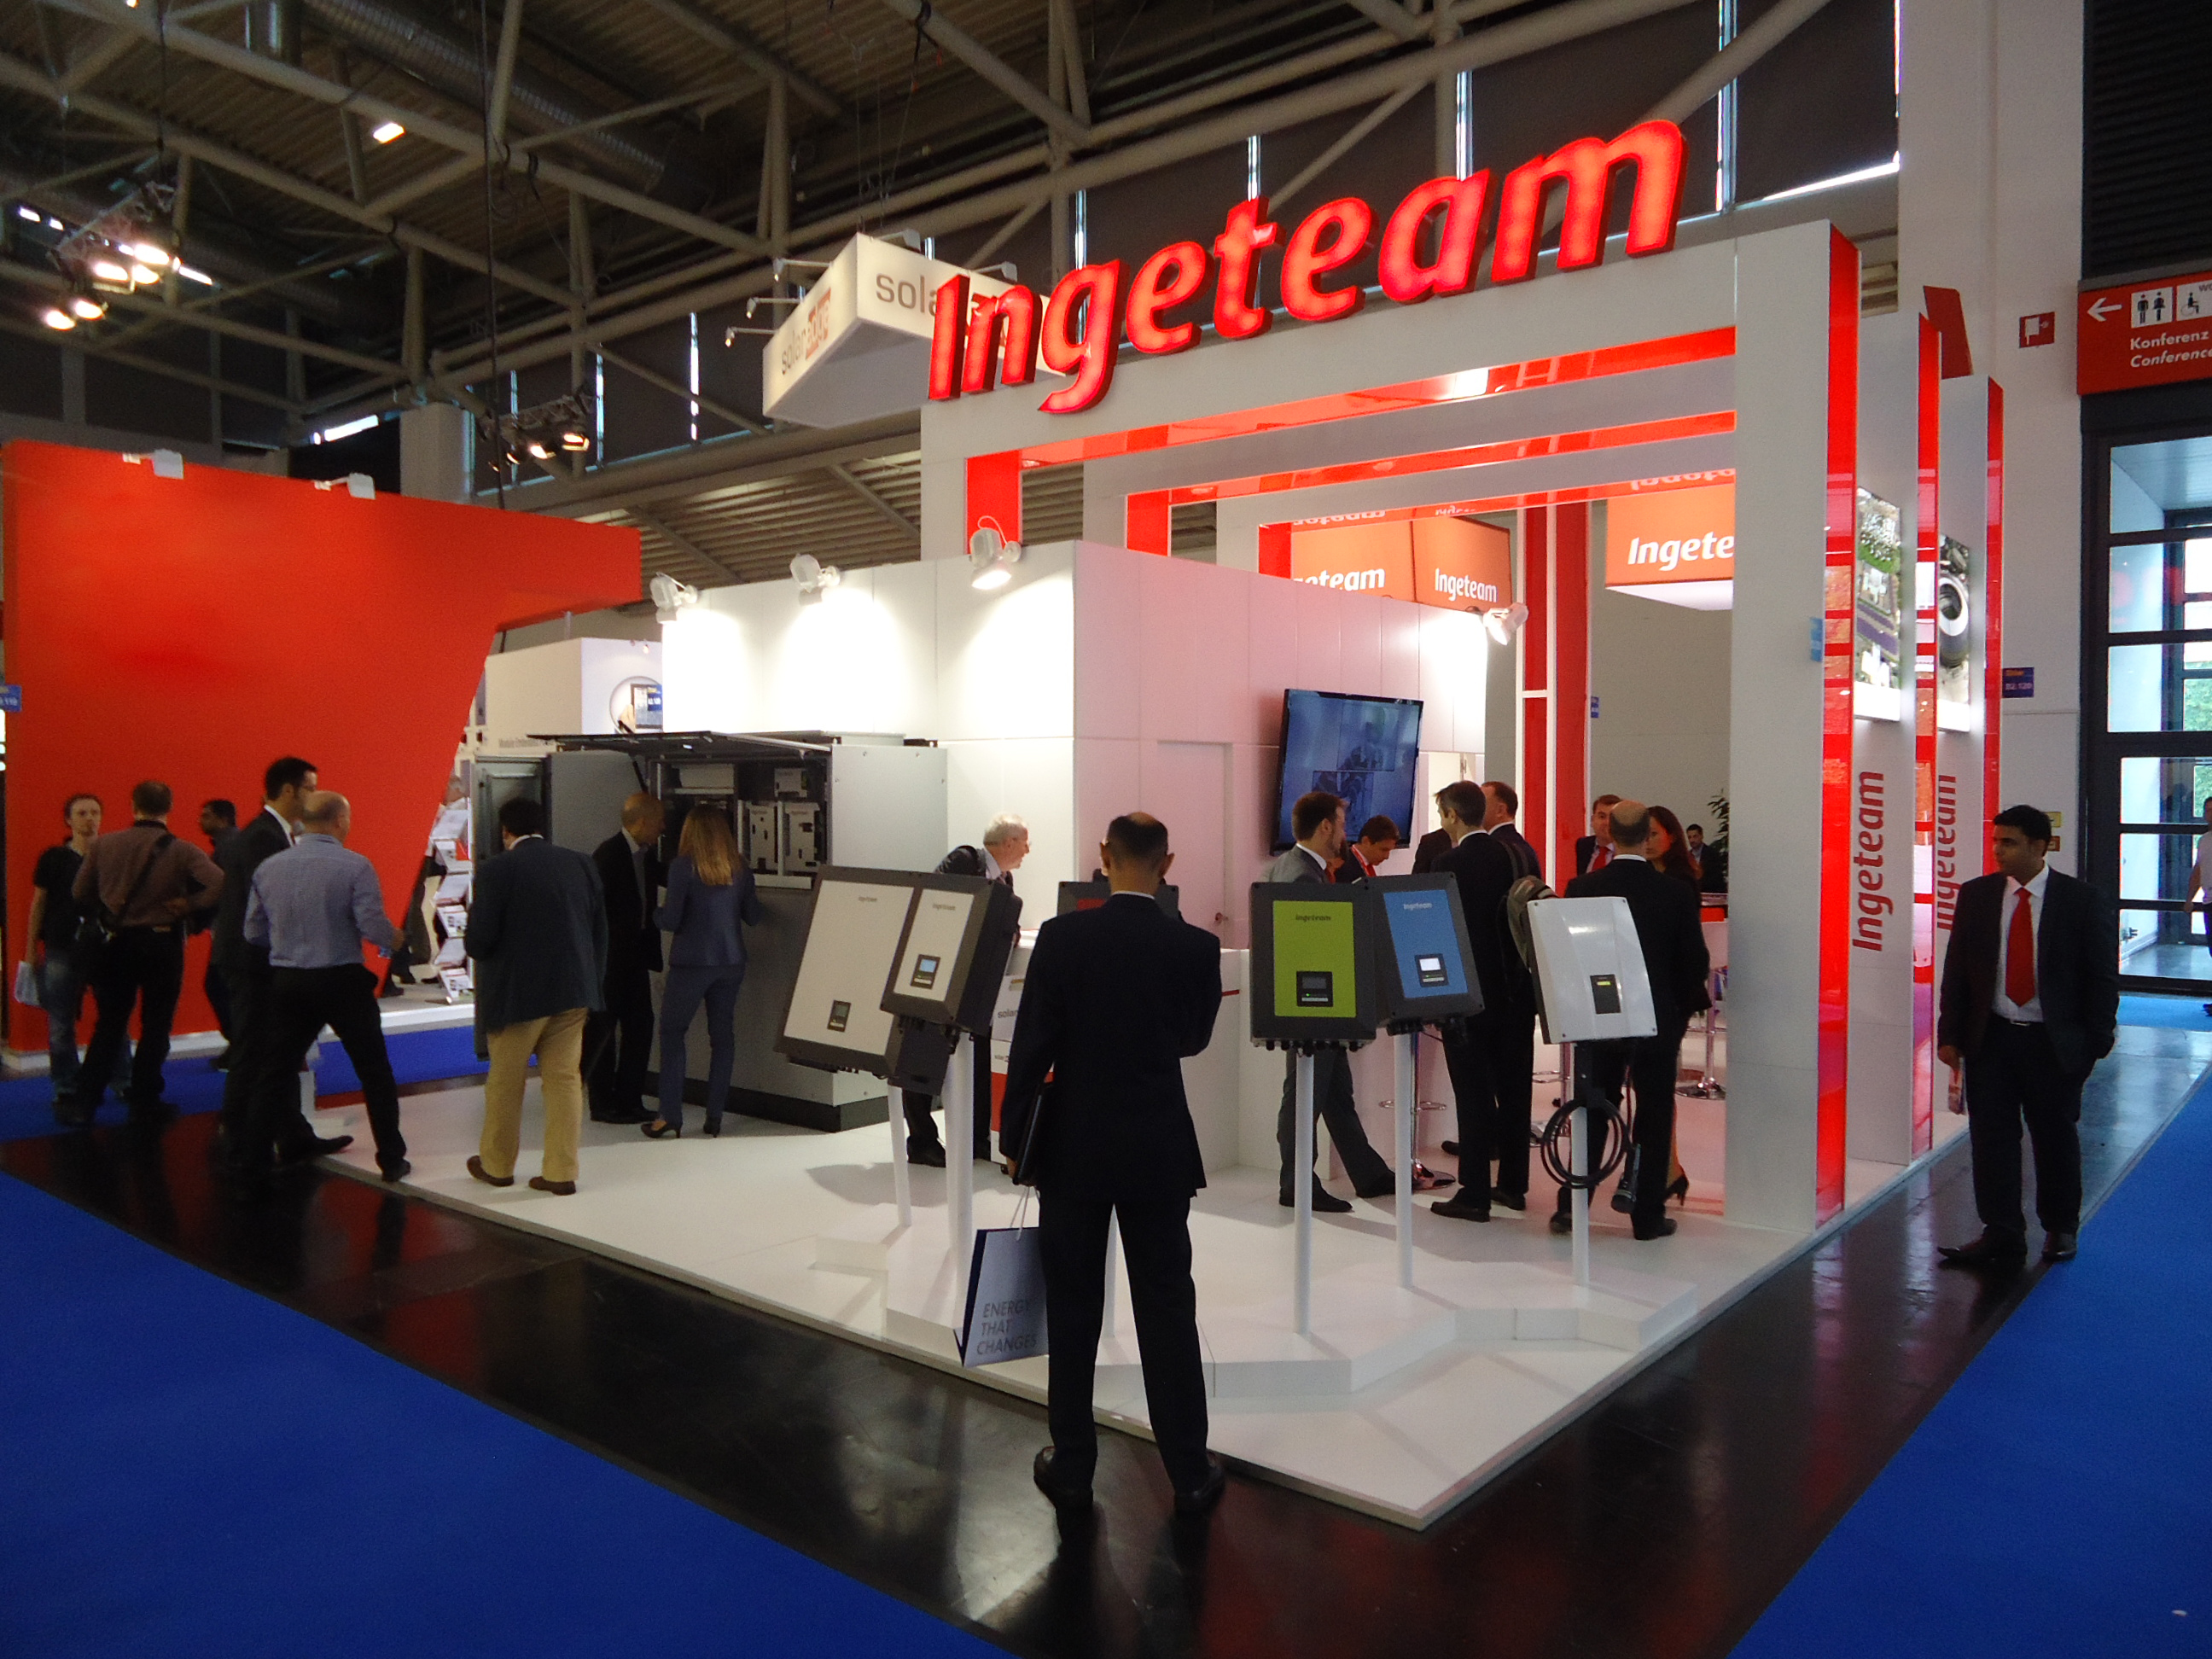

Pamplona, 14 May 2015. Once again, Ingeteam will be present at Intersolar Europe, the world's leading solar trade fair, where it will exhibit its main technological solutions for the solar energy sector, self-consumption, energy storage and e-mobility. The 2015 edition will be held yet again at the Messe München exhibition centre in Munich, from the 10th to 12th June.
Roberto González, the Ingeteam Technical Director for the Solar area will present a paper at the EES forum (Electrical Energy Storage), setting out the key technical features of Ingeteam's battery inverters. This forum, sponsored by Ingeteam, consists in a cycle of conferences on energy storage technologies given by experts from companies within the sector.
On its stand, Ingeteam is to showcase its single-phase and three-phase string inverters, both of which are suitable for operation in self-consumption mode. Visitors will also get the opportunity to see the outdoor version of Ingeteam's new INGECON SUN PowerMax monoblock central inverters, in addition to its 2.33 MVA solution in a single medium voltage centre.
Also on show will be Ingeteam's single-phase and three-phase battery inverters, within the INGECON SUN STORAGE range. These inverters, originally designed for stand-alone systems, can also operate connected to the public grid, offering self-consumption, grid support and back-up functions. The Diesel-PV hybridization solution will be yet another point of interest at stand B2.120.
Finally, e-mobility is a business with a category of its own within the energy sector. For this reason, electric vehicle charging stations will also be present at Intersolar. This year Ingeteam is to showcase the recently launched INGEREV CITY Duo, the dual charging station. Visitors will also get the chance to see the INGEREV GARAGE Basic station, designed for private use.
Come and visit us at Intersolar Europe, at stand 120 Hall B2 .

Ingeteam
Ingeteam is a leading company specialising in the design of power and control electronics (frequency converters, process automation and control), electrical machines (generators and motors), electrical engineering and generating plants.
Ingeteam develops its products in four key sectors: energy; industry; marine; and rail traction, always seeking to optimise energy consumption and to maximise generating efficiency
The company operates throughout the world, with a headcount of around 3,000 employees. R&D is the backbone of Ingeteam's business activity, in which 9% of the company's turnover is invested annually.

For more information:
irene.marin@ingeteam.com
carlos.lezana@ingeteam.com
Follow us on:    

